26.12: From Ohm’s law, the voltage drop across the 6.00  resistor is V = IR = 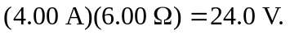 The voltage drop across the 8.00 resistor is the same, since these two resistors are wired in parallel. The current through the 8.00 resistor is then The current through the 25.0 resistor is the sum of these two currents: 7.00 A. The voltage drop across the 25.0 resistor is V = IR = (7.00 A)( 25.0 ) = 175 V, and total voltage drop across the top branch of the circuit is 175 + 24.0 = 199 V, which is also the voltage drop across the 20.0 resistor. The current through the 20.0 resistor is then 